# SkyTeam PER Analysis Dashboard Report

## Introduction

This report provides an analysis of the SkyTeam Partner Enabled Revenue (PER) across the Virgin Atlantic network. The analysis is based on the SkyTeam PER dashboard, which consolidates key metrics such as total revenue, total seats sold, and average revenue per seat. This report aims to highlight the performance of individual SkyTeam carriers, assess the contribution of key Origin-Destination (OD) pairs, and provide strategic recommendations based on the findings.

# Dashboard

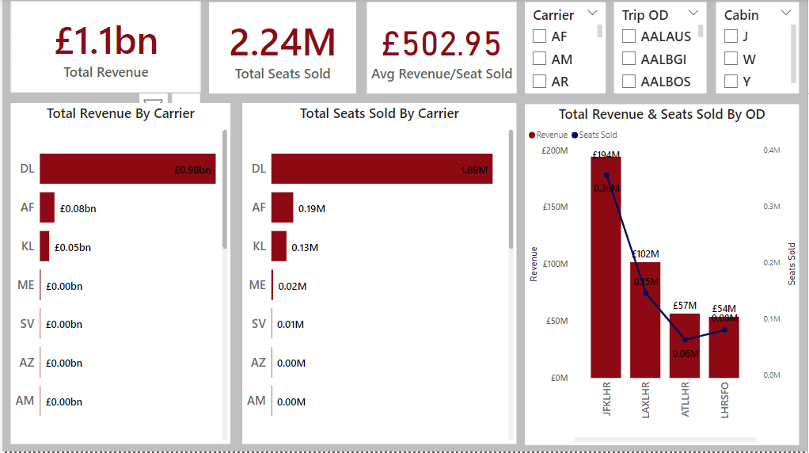

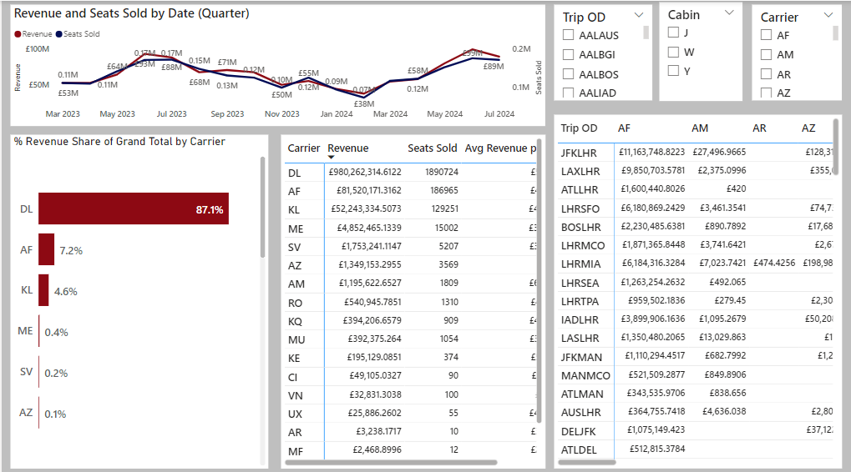

## High-Level Overview

### Key Metrics

* **Total Revenue**: £1.1bn
* **Total Seats Sold (Passengers)**: 2.24M
* **Average Revenue per Seat Sold**: £502.95

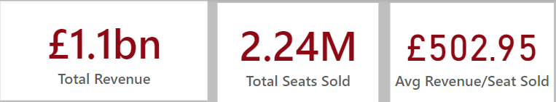

### Visual Analysis

1. **Total Revenue by Carrier**:
   * **Delta Airlines (DL)** is the dominant carrier, generating £0.98bn, which is significantly higher than other carriers.
   * **Air France (AF)** follows with £0.08bn, and **KLM (KL)** with £0.05bn.
   * The remaining carriers, including ME, SV, AZ, and AM, contribute minimally to the overall revenue.

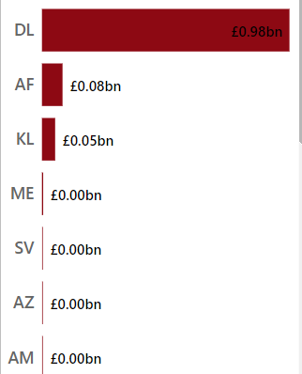

1. **Total Seats Sold by Carrier**:
   * **Delta Airlines (DL)** also leads in the total number of seats sold, with 1.89M seats, representing the highest passenger volume.
   * **Air France (AF)** and **KLM (KL)** follow with 0.19M and 0.13M seats sold, respectively.
   * Other carriers have sold very few seats, with some showing negligible contributions.

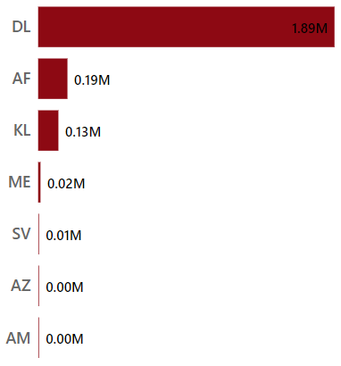

1. **Total Revenue & Seats Sold by OD**:
   * The **JFK-LHR** OD pair stands out as the most lucrative route, generating £194M in revenue with 0.36M seats sold.
   * Other high-performing ODs include **LAX-LHR** (£102M, 0.15M seats) and **ATL-LHR** (£57M, 0.06M seats).
   * These routes are critical for maintaining overall revenue and seat occupancy levels.

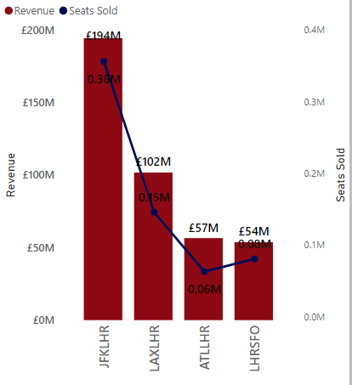

## Detailed Analysis

**Revenue and Seats Sold by Date (Quarter)**

* **Trend Analysis**:
  + Revenue and seat sales fluctuate throughout the year, with notable peaks in May 2023 (£88M revenue, 0.17M seats) and November 2023 (£55M revenue, 0.12M seats).
  + A significant dip is observed in January 2024, with revenue dropping to £38M and seats sold decreasing to 0.07M.
  + The data indicates seasonality in revenue and seat sales, suggesting the need for targeted marketing and resource allocation during peak travel times.

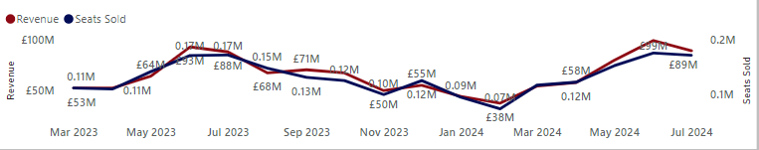

**% Revenue Share of the Grand Total by Carrier**

* **Carrier Dominance**:
  + **Delta Airlines (DL)** accounts for 87.1% of the total revenue, underscoring its importance to the Virgin Atlantic network.
  + **Air France (AF)** and **KLM (KL)** contribute 7.2% and 4.6%, respectively, making them the second and third most significant carriers.
  + Other carriers contribute less than 1% each, indicating potential areas for growth or re-evaluation of partnerships.

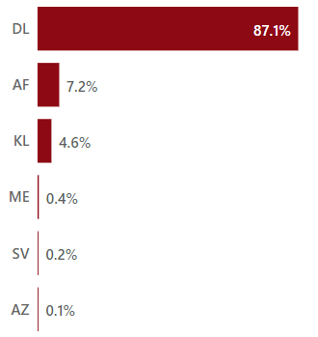

**Tabular Breakdown: Carrier, Revenue, Seats Sold, Average Revenue per Seat**

* **Detailed Carrier Performance**:
  + The tabular data provides a granular view of each carrier’s performance in terms of revenue, seats sold, and average revenue per seat.
  + **Delta Airlines (DL)** continues to lead with the highest revenue and seats sold, while **Air France (AF)** and **KLM (KL)** show moderate performance.
  + Some carriers, such as **ME** and **SV**, exhibit low revenue and seat numbers, suggesting a need for further analysis or strategic changes.

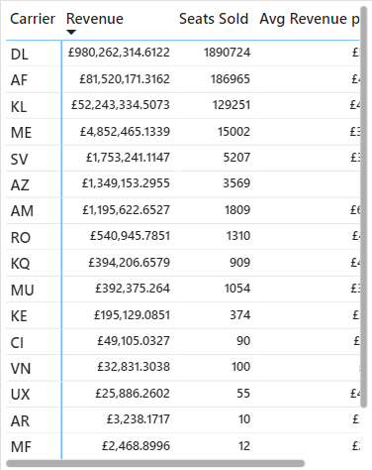

**Pivot Table: Trip OD, Carrier, Revenue**

* **OD Pair Analysis**:
  + The pivot table reveals the revenue contribution of various OD pairs across different carriers.
  + High-revenue OD pairs like **JFK-LHR** and **LAX-LHR** are predominantly served by **Delta Airlines (DL)**, **Air France (AF)**, and **KLM (KL)**.
  + The data highlights the concentration of revenue in specific routes, which could be targeted for further development.

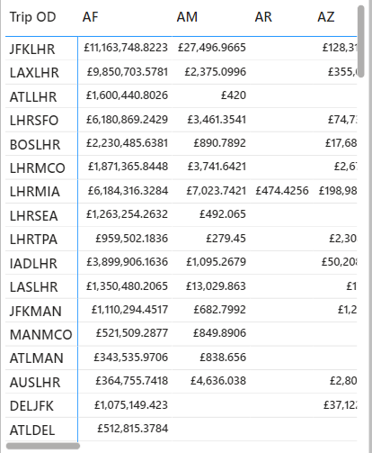

## Conclusions & Recommendations

### Key Insights

* **Delta Airlines (DL)** is the cornerstone of Virgin Atlantic's SkyTeam partnership, contributing the majority of the revenue and passenger volume.
* The **JFK-LHR** route is the most profitable OD pair, emphasizing its strategic importance.
* Other carriers and OD pairs contribute significantly less, indicating potential areas for improvement or increased focus.

### Recommendations

1. **Strengthen the Partnership with Delta Airlines**:
   * Given Delta’s significant contribution, expanding marketing efforts and partnership initiatives with DL could further enhance revenue.
2. **Optimize Resource Allocation for High-Performing Routes**:
   * Focus on maximizing the profitability of high-revenue OD pairs like JFK-LHR and LAX-LHR through targeted promotions and enhanced customer experiences.
3. **Explore Growth Opportunities for Underperforming Carriers**:
   * Investigate why carriers like **Air France** and **KLM** are lagging behind DL, and develop strategies to increase their market share.
   * Consider reallocation of resources or marketing efforts to improve performance on routes that currently generate minimal revenue.